Q#1 Biosurfactant define?
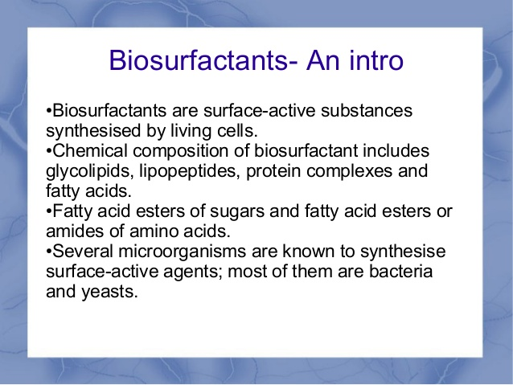

Q#2 Vacine define?
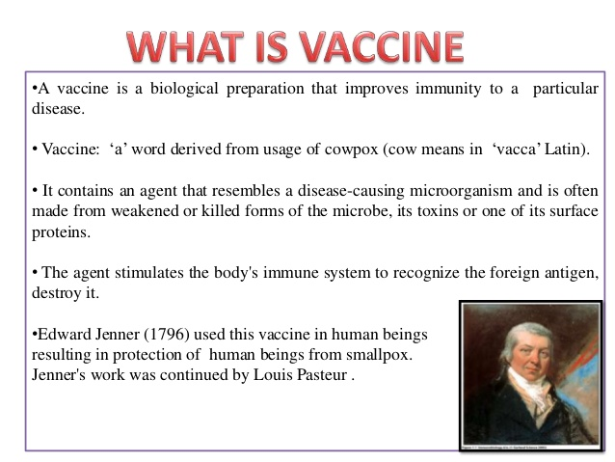

Q#4 Soil treatment?
• All the bio fertilizers along with the compost fertilizers are mixed together.
• They are kept for one night. Then the next day the mixture is spread on the soil where
seeds have to be sown.
Q#5role of microbes in petroleum industry?
Petroleum-based products are the major source of energy for industry and daily life. Leaks and accidental spills occur regularly during the exploration, production, refining, transport, and storage of petroleum and petroleum products. • Release of hydrocarbons into the environment whether accidentally or due to human activities is a main cause of water and soil pollution
• Soil contamination with hydrocarbons causes extensive damage of local system since accumulation of pollutants in animals and plant tissue may cause death or mutations
• Microbial processes play an important role in industry, the protection of the natural environment
• Several practical applications of microbial processes are listed as follows
Bioremediation • Bioremediation is a natural process that involves the use of biological entities to neutralize the contaminated site
• Microbial biodegradation is the use of bioremediation and biotransformation methods to harness the naturally occurring ability of microbial xenobiotic metabolism to degrade, transform or accumulate environmental pollutants, including hydrocarbons (e.g. oil), polychlorinated biphenyls (PCBs), polyaromatic hydrocarbons
Biosurfactants • These are microbial-synthesized surface-active substances that allow for more efficient microbial biodegradation of hydrocarbons in bioremediation processes.
• There are two ways by which biosurfactants are involved in bioremediation
• 1) Increase the surface area of hydrophobic water-insoluble substrates. Growth of microbes on hydrocarbons can be limited by available surface area of the water-oil interface. Emulsifiers produced by microbes can break up oil into smaller droplets, effectively increasing the available surface area.
• 2) Increase the bioavailability of hydrophobic water-insoluble substrates. Biosurfactants can enhance the availability of bound substrates by desorbing them from surfaces (e.g. soil) or by increasing their apparent solubility. Some biosurfactants have low critical micelle concentrations (CMCs), a property which increases the apparent solubility of hydrocarbons by sequestering hydrophobic molecules into the centres of micelles.
• Microbial Enhanced Oil Recovery (MEOR) • One of the major concerns facing the oil industry today is the recovery of the large percentage of oil remaining unrecovered in mature and in nearly depleted oil fields.
• Microbes can influence and improve the oil recovery process by: • generating gases that increase reservoir pressure and decrease oil viscosity
• generating acids that dissolve rock, thus improving absolute permeability
• reducing permeability in channels • producing bio-surfactants that decrease interfacial tension
• reducing oil viscosity by degrading long-chain saturated hydrocarbons
Q#6 Live attnuated vaccine?example? (3)
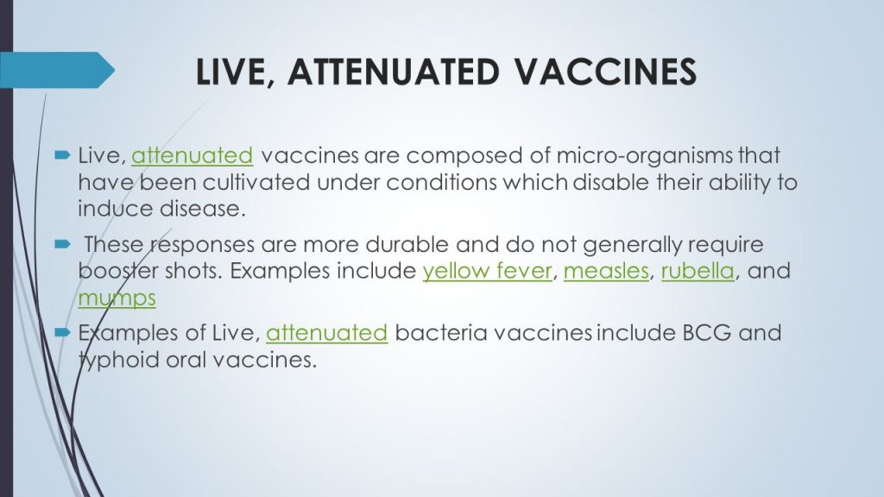

Q#7 Steps of vacine production?
The production of a vaccine can be divided in the following steps:
1. Generation of the antigen
The first step in order to produce a vaccine is generating the antigen that will trigger the immune response. For this purpose the pathogen’s proteins or DNA need to be grown and harvested using the following mechanisms:
Viruses are grown on primary cells such as cells from chicken embryos or using fertilised eggs (e.g. influenza vaccine) or cell lines that reproduce repeatedly (e.g. hepatitis A)
Bacteria are grown in bioreactors which are devices that use a particular growth medium that optimises the production of the antigens
Recombinant proteins derived from the pathogen can be generated either in yeast, bacteria or cell cultures.
2. Release and isolation of the antigen
The aim of this second step is to release as much virus or bacteria as possible. To achieve this, the antigen will be separated from the cells and isolated from the proteins and other parts of the growth medium that are still present.
3. Purification
In a third step the antigen will need to be purified in order to produce a high purity/quality product.
This will be accomplished using different techniques for protein purification. For this purpose several separation steps will be carried out using the differences in for instance protein size, physico-chemical properties, binding affinity or biological activity.
4. Addition of other components
The fourth step may include the addition of an adjuvant, which is a material that enhances the recipient’s immune response to a supplied antigen. The vaccine is then formulated by adding stabilizers to prolong the storage life or preservatives to allow multi-dose vials to be used safely as needed. Due to potential incompatibilities and interactions between antigens and other ingredients, combination vaccines will be more challenging to develop. Finally, all components that constitute the final vaccine are combined and mixed uniformly in a single vial or syringe.
5. Packaging
Once the vaccine is put in recipient vessel (either a vial or a syringe), it is sealed with sterile stoppers. All the processes described above will have to comply with the standards defined for Good Manufacturing Practices that will involve several quality controls and an adequate infrastructure and separation of activities to avoid cross-contamination, as shown in the diagram below. Finally, the vaccine is labelled and distributed worldwide.

Q#8 charging electronics?
Charging Electronics • According to scientists from Saint Luis University, a fuel cell was developed with cooking oil and sugar to generate electricity
• consumers will be able to use these cells instead of generating electricity. • Consumers may be able to use fuel cells in place of batteries to charge anything from computers to cell phones

Q#9 Biofuel?
A biofuel is a fuel that is produced through contemporary biological processes, such as agriculture and anaerobic digestion, rather than a fuel produced by geological processes such as those involved in the formation of fossil fuels, such as coal and petroleum, from prehistoric biological matter. • Another growth area in this century will be the development of alternatives to nonrenewable resources especially fossil fuels. Biotechnology will provide answers through modified enzymes and microorgamisms that can turn abundant biomass into feedstocks for the production of synthetics, plastics, polymers and bio-fuels like Ethanol • Therefore, production of ethanol can spark new capital investment and economic development in rural communities across Pakistan

Q#10 Nitrogen bio fertilizers?
• The sort of bio fertilizers can help any farmers to determine the nitrogen point during the solid ground. Nitrogen may be a crucial factor which happens to be put to use in any growing for put.
• Including, Azotobacteria must be used to your non-legume bounty; Rhizobium it takes to your legume bounty. Purple earth-friendly algae are needed to progress hemp despite the fact that Acetobacter must be used to progress sugarcane

Q#11 Steroids ?
• Steroids are a very important group of chemicals, which are used as anti-inflammatory drugs, and as hormones such as estrogens and progesterone, which are used in oral contraceptives.
• Producing steroids from animal sources or chemically systhesising them is difficult, but microorganisms can synthesise steroids from sterols or from related compounds

Q#12 DNA Vaccines?
• Still in the experimental stages, these vaccines show great promise, and several types are being tested in humans.
• • DNA vaccines take immunization to a new technological level. • • These vaccines dispense with both the whole organism and its parts and get right down to the essentials: the microbe’s genetic material.
• • Example: Influenza vaccine.

Q#13 wr!te the name of v!tam!ns that are produce w!th m!crobes?
Vitamins are some organic compounds which are capable of performing many lifesustaining functions inside our body. • These compounds cannot be synthesised by humans, and therefore, they have to be supplied in small amounts in the diet.
• Microbes are capable of synthesizing these compounds and hence they can be used for the commercial production of many of the Vitamins e.g. thiamine (Vitamin B1), riboflavin (Vitamin B2)

Q#14 Microbial Enhanced Oil Recovery (MEOR)?
• One of the major concerns facing the oil industry today is the recovery of the large percentage of oil remaining unrecovered in mature and in nearly depleted oil fields.
• Microbes can influence and improve the oil recovery process by: • generating gases that increase reservoir pressure and decrease oil viscosity
• generating acids that dissolve rock, thus improving absolute permeability
• reducing permeability in channels • producing bio-surfactants that decrease interfacial tension
• reducing oil viscosity by degrading long-chain saturated hydrocarbons
Q#15 Worm composting?
Worm composting is using worms to recycle food scraps and other organic material into a valuable soil amendment called vermicompost, or worm compost.
Q# 16 advantages of biopesticides?
